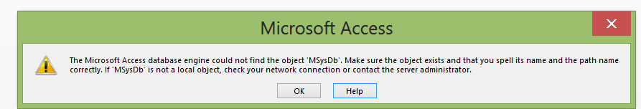

The Microsoft acess database engine could not find the object MySysdb make sure the object exists and that you spell its name and the path name correctly if MySysdb is not a local object check your network connection or contact the server administrator

