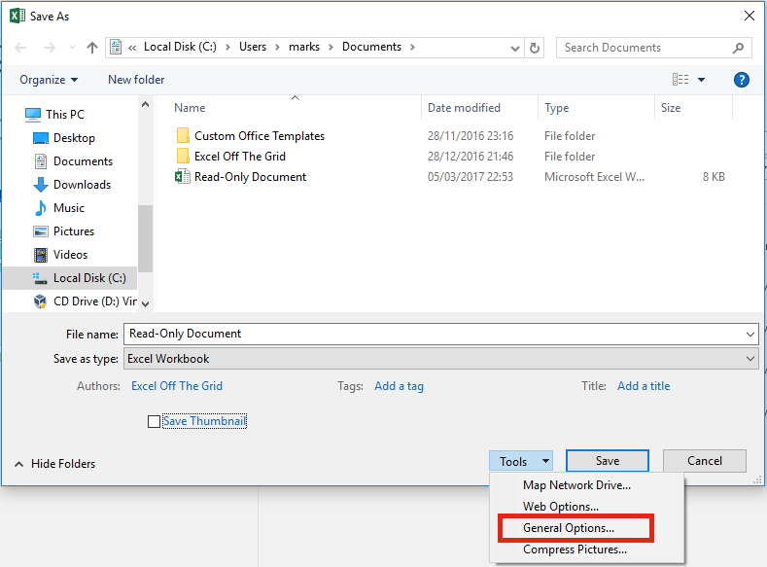
From the Save As window click Tools -> General Options…
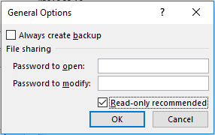
From the General Options window select the read-only recommended option. Click OK. Then save the file.
When the file is opened, a message is displayed asking the user if they wish to open as read-only.
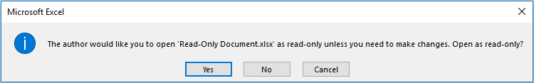
The biggest issue with this option is that the user can click ‘No’. The file will be opened, but not as read-only.

Save the file as “read-only” with a password
Using the same method as described above, a password can be entered. It is important that the password is only set for modifying the document. If you set a password to open the document the users will not be able to open the file without a password.
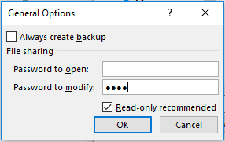Enter a password to make Read-only 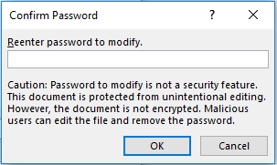Passwords are not 100% secure
Passwords entered using this method are not encrypted and can be cracked. Therefore, anybody who really, really wants to could get access to your document.
This is certainly more stringent than the non-password option. The user must open the file as read-only unless they have the password.
