GENERAL

The design basis described herein establishes general criteria applicable to structural engineering works for the design of the MOJ – Courts Complex in Jeddah, Saudi Arabia

CODE AND STANDARDS REFERENCES

Reference specifications were based on the following specifications and standards and shall be applicable to the design of the permanent structural elements of the project.

The following are the governing structural codes and standards:

Structural Loads
SBC 201 - CR, 2018 | Saudi Building Code 2018 Gen., Ch.16
SBC 301– CR, 2018 | Saudi Loading Code 2018
SBC 302 - E, 2018 | Saudi Construction Code, Chapter 3
IBC 2018 | International Building Code 2018, Ch. 16
ASCE-SEI 7-16 | Minimum Design loads for Buildings and Other Structures

Steel Construction
SBC 201- CR, 2018 | Saudi Building Code General, Ch 22
SBC 306–CR, 2018 | Saudi Steel Structures Code
AISC 360,latest ed. | Specification for Structural Steel Buildings
AISC 341,  latest ed. | Seismic Provisions for  Structural Steel Buildings
AWS D1.1 | Structural Welding Code – Steel.
MBMA | MBMA Design Manual
SSPC | Steel Structure Painting Manual
SCI Publication 094 | The Fire Resistance Of Composite Floors With Steel Decking

Concrete Construction
SBC 304 E , 2018 | Saudi Concrete Structural Code
SBC 201, 2018 | Saudi Building Code General, Ch.19
ACI 318M, 2019 | Building Code Requirements for Structural Concrete
ACI 305 / SBC 302 E, 2018 | Hot Weather Concreting / Saudi Construction Code, Ch. 10
ACI 315, latest ed. | Manual of Standard Practices for Detailing Reinforced Concrete Structures
ACI 322, latest ed. | Building Code Requirement For Structural Plain Concrete.
ACI 360, latest ed. | Design of Slabs on Grade
ACI 224.3, lat. ed. | Joints in Concrete Construction
ACI 523.3R, latest ed. | Guide to Cellular Concrete Above 800kg/m³
ACI MCP, lat ed. | American Concrete Institute, Manual of Concrete Practice
PCI Design Manual, 7th Ed | Precast / Pre-stressed Concrete Institute Design Manual
CPCI Design Manual, 4th Ed | Canadian Precast / Pre-stressed Concrete Institute Design Manual
PTI DM, 6th Ed | Post Tensioning Institute Design Manual
Concrete Society  TR No. 43 | Technical Report No. 43. Post Tensioned Concrete Floors Design Handbook

Masonry Construction
SBC 201-CR- 2018 | Saudi Building Code General, Ch. 21
SBC 305 E – 2018 | Saudi Masonry Code
ACI 530/530.1 | Building Code Requirements for Masonry Structures

Other Standards / References
SASO | Saudi Arabian Standards Organization.
BS | British Standards.
SBC 302 | SBC Structural Testing And Inspection
SBC 303 E - 2018 | Saudi Soils And Foundation Code
Bijan O. Aalami &  Allan Bommer | Design Fundamentals Of Post-tensioned Concrete Floors
TM-65 (FCCB) | Expansion Joints In Buildings
ATC DG1, 1999 | Design Guide 1, Minimizing Flr. Vibration
ASTM Standards | American Society for Testing of Materials Standards
MOT | Highway Design Manual
SAES-A-112 | Saudi Aramco Meteorological and Seismic Design Data

Abbreviation
AISC | American Institute of Steel Construction
ACI | American Concrete Institute
ASCE | American Society of Civil Engineers
ATC | Applied Technology Council
AWS | American Welding Society
IBC | International Building Code
MBMA | Metal Building Manufacturers Association
MOT | Ministry of Transportation
PCA | Portland Cement Association
PCI | Precast / Pre-stressed Concrete Institute
PTI | Post Tensioning Institute
SAES | Saudi Aramco Engineering Standards
SBC | Saudi Building Code
SCI | Steel Construction Institute
SDI / SJI | Steel Deck Institute / Steel Joist Institute

STRUCTURAL DESIGN BASIC REQUIREMENTS

In order to achieve satisfactory structural design and performance, the buildings and other structures design shall consider the following basic requirements

DESIGN LIFE

The structural design service life of the project is 50 years or as prescribed in the project contract documents.

ADEQUATE STRENGTH AND STIFFNESS

Buildings and other structures shall be designed and constructed with adequate strength and stiffness to provide structural stability, protect non-structural components and systems from unacceptable damage, to resist the applicable loads and meet the serviceability requirements. Acceptable strength shall be demonstrated using Strength/Ultimate Design Procedures.

ADEQUATE GENERAL STRUCTURAL INTEGRITY AND CONTINUOUS LOAD PATH

Primarily all structures shall comply with the structural Integrity requirements of SBC 201-2018 Section 1615 and ACI 318-19M Section 4.10. It shall be provided with a continuous load path in accordance with the requirements of ASCE 7-16 Section 1.4.1 to 1.4.4.

ADEQUATE SERVICEABILITY AGAINST LATERAL DRIFTS, DEFLECTIONS, DEFORMATIONS AND VIBRATION.

Designed under service loads to have adequate stiffness to limit deflections, lateral drift, any other deformations and floor vibration that adversely affect the building intended use based on requirements set forth in these design criteria.

ANTICIPATES SELF-STRAINING FORCES AND EFFECTS

Provisions shall be made for anticipated self-straining forces arising from differential settlements/ vertical movements of foundations and from restrained dimensional changes caused by temperature, moisture, shrinkage, creep and similar effects.

STRUCTURAL ANALYSIS ACCOUNTS EQUILIBRIUM, GENERAL STABILITY, GEOMETRIC COMPATIBILITY, AND BOTH SHORT & LONG-TERM MATERIAL PROPERTIES

Load effects on individual structural members shall be determined by methods of structural analysis that take into account equilibrium, general stability, geometric compatibility, and both short- and long-term material properties. Members that tend to accumulate residual deformations under repeated service loads shall include in their analysis the added eccentricities expected to occur during their service life.

COUNTERACTING STRUCTURAL ACTIONS AND PROVIDE ADEQUATE STABILITY AGAINST OVERTURNING, SLIDING AND FLOATATION/UPLIFT.

Designed with appropriate factor of safety to resist forces due to earthquake and wind, flotation/hydrostatic uplift pressure, lateral soil / water pressure with consideration of overturning, sliding, uplift and floatation.

FIRE RESISTANCE

Design for fire resistance in accordance with the NFPA, IBC, PCI, PTI, AISC, ACI and SBC code.

DURABILITY

Designed to tolerate long term environmental effects and shall be protected against such effects during its service life.

ECONOMICAL

During the design process, it is essential to consider construction cost, construction time and maintenance costs.

AESTHETICS MATCHES ARCHITECTURE

Structural design shall be consistent with the approved Architectural and coordinated with other engineering disciplines.

STANDARD OF MEASUREMENTS
The modern metric System International (SI) will be applied.

STRUCTURAL RISK CATEGORIZATION
The Structures risk category shall be based on SBC 301-CR-2018 Table 1-2 and ASCE 7 Figure C1.5-1. It is recommended that all the buildings to be classified as Risk Category III except for utilities buildings that are required to maintain water pressure for fire suppression is classified as Risk Category IV.
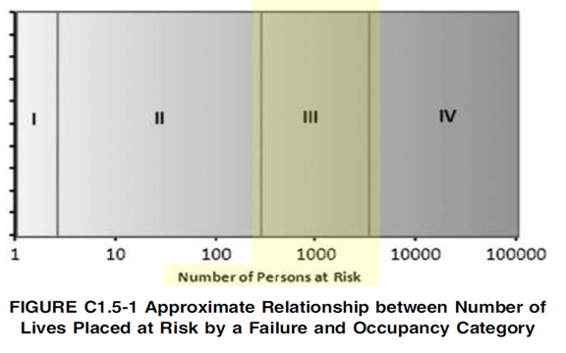

Base on the structures risk category, importance factor shall be specified to enhance its resistance against the effect of lateral loads. In the structure’s lateral loads analysis, the seismic analysis/ design importance factor shall consider Ie=1.25 and Ie=1.50 for Risk Category III and IV buildings respectively.

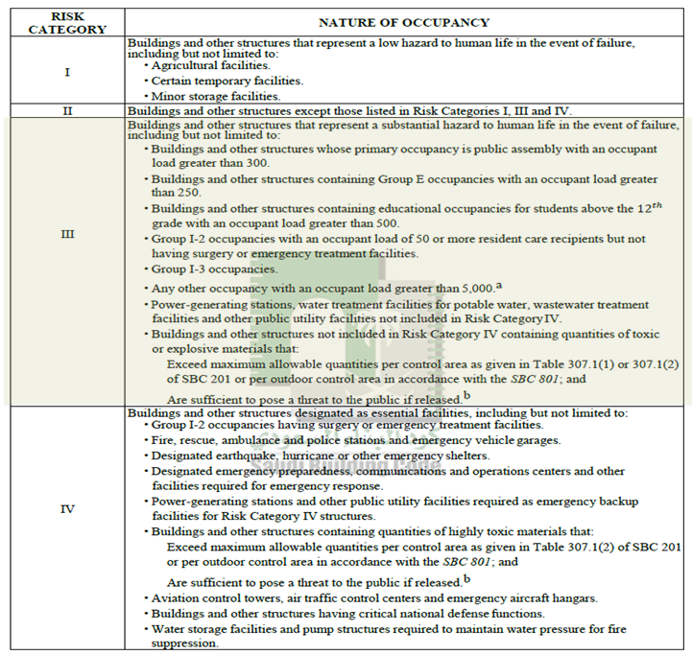

MATERIALS STRENGTHS
Proposed material specifications and strengths are referenced herein:

Minimum Concrete Cylinder Compressive Strengths at 28 days
Element | fc’, mPa | Max. W/C Ratio | Unit Weight  (kN/m³)
Plain Concrete | 20 | 0.40 | 22
Administration (Tower) Building and Multi Story Parking Building, CIP Reinforced Concrete Columns and Shear Walls | 50 | 0.40 | 25
Judicial Court, CIP Reinforced Concrete Columns and Shear Walls | 40 | 0.40 | 24
CIP RC and/or PT Floor Framing Systems and CIP RC Foundation (Shallow and Deep Foundation) | 40 | 0.40 | 24
Precast (Reinforced and Pre-stressed) Concrete Elements | 45 | 0.40 | 25
Low Rise Buildings (UNO), Underground Tanks, and Structural Screed/ Precast Str. toppings. | 35 | 0.40 | 24
Light Weight RC for Composite Steel Decks | 21 | 0.50 | 19
All Other CIP RC Element not mentioned | 30 | 0.40 | 24
Note: Cement type for reinforced concrete in contact with ground will be cement type (I) with micro silica. All others shall be type (I) cement

Minimum Reinforcement Steel Yield Strengths
Element | Fy, mPa | Specification
Deformed Bars | 420 | ASTM A 615/A 615M, Grade 60, and SASO SSA 2,
Welded Wire Fabric | 500 | ASTM A 497(deformed), ASTM A 185 (plain), or BS4483
Uncoated Low Relaxation Seven-Wire Strands for pre-stressed concrete | fpu=1860 and fpy=0.9fpu | ASTM A416 or BS5896

Minimum Structural Steel Yield Strengths
Element |  | fy, mPa | Specification
Built-up Sections |  | 345 | ASTM A572M Grade 50
Hot Rolled | Beams | 345 | ASTM A572M Grade 50
Hot Rolled | Columns | 345 | ASTM A572M Grade 50
Hot Rolled | Channels UPN | 345 | ASTM A572M Grade 50
Hot Rolled | Channels PFC | 345 | EN- S355JR
Cold Formed | Black | 345 | ASTM A607 Grade 50
Cold Formed | Galvanized | 345 | ASTM A 653 SS 50 Class 1
Exterior Wall & Roof Panels |  | 345 | ASTM A792M Grade 345B
Interior Liner Panels |  | 345 | ASTM A792M Grade 345B
X-Bracing | Angles | 345 | ASTM A572M Grade 50
X-Bracing | Cable | Minimum Breaking Strength of Strand (ASTM A475-03 Table 1) | ASTM - A475 - Extra High Strength Class A
Anchor Bolts |  | 248 and 380 | ASTM F1554 Grade 36 and Grade 55
High Strength Bolts | (Hot Dip Galv.) Grade 8.8 | 660 | ASTM A 325 M / A 449
High Strength Bolts | (Hot Dip Galv.) GRADE 10.90 | 940 | ASTM A 490 M
Machine Bolts (Electro Plated Yellow Chromate) Grade 4.6/4.8 |  | 240 | ASTM A 307
Steel Deck |  | 230 to 275 | ASTM A653 Type SS or ASTM A446

DESIGN LOADS
  - DEAD LOADS (D)

Dead loads consist of the weight of all materials of construction incorporated into the building including, but not limited to, walls, floors, roofs, ceilings, stairways, built-in partitions, finishes, cladding, and other similarly incorporated architectural and structural items and fixed service equipment, including the weight of cranes and material handling systems.

For minimum dead loads and material densities, refer to SBC 301 Table 3-1 to 3-3. For construction loads and formwork design, refer to the SBC 302 E, particularly part1

Minimum Material Density and Uniformly Distributed Dead Loads
Description | Loads
Reinforced concrete and Pre-stressed Concrete | 24 kN/m³
High Strength (fc’≥45) Reinforced Concrete and Pre-stressed Concrete | 25 kN/m³
Glass | 25 kN/m³
Marble and Aluminum | 27 kN/m³
Steel | 77.50 kN/m³
Light Weight / Cinder Concrete Floor Fill, Gravel (dry) | 17 kN/m³
Sand Backfilling, Gravel Overlay, Plain Concrete Floor Fill and Mortar | 20 kN/m³
Foam Concrete and gypsum wall board | 8 KN/m³
Suspended Ceiling (unless heavier ceiling system exist) | 0.30 KN/m²
Suspended M&E, and PG Utilities (unless heavier system exist) | 0.20 KN/m²
Plastered Slab Soffit (exposed soffit or no ceiling) and masonry wall plaster per face | 0.40 KN/m²
Dry walls partition (including the light weight frame supports) | 1 Kn/m²(min)
Non Load Bearing Masonry Wall, (SBC 301 Table 3-1a) – if light weight units are specified | 16.50 Kn/m³
Non Load Bearing Masonry Walls, (SBC 301 Table 3-1a) – Medium Weight Units (used UNO) | 19.50 Kn/m³
Load Bearing Masonry Walls , (SBC 301 Table 3-1a)  – Normal Weight Units | 21 Kn/m³
200mm thick CMU (un plastered) w/ 400mm cell grout spacing , UNO | 3.5Kn/m² x h
150mm thick CMU (un plastered) w/ 400mm cell grout spacing, UNO | 2.8Kn/m² x h
100mm thick CMU (un plastered) w/ 400mm cell grout spacing, UNO | 2.1Kn/m² x h
200mm thick solid or fully grouted cell CMU (un plastered) | 4.5Kn/m² x h
Insulation (Polystyrene), UNO | 0.035 Kn/m³
Insulation (Rock Wool and Polyurethane), UNO | 0.7 Kn/m³
Cladding System Including its Structural Support System  (varies, refer to Architectural for specific materials) | Actual
Building Maintenance Unit (As per approve system vendor details) | Actual

  - LIVE LOAD (L, L5)

Load produced by the use and occupancy of the building or other structure that does not include construction or environmental loads, such as wind load, snow load, rain load, earthquake load, flood load, or dead load.

Minimum Uniformly Distributed Live Loads, And Minimum Concentrated Live Loads or as specified herein or shall be in accordance with SBC-301-CR-18 Table 4-1.

Minimum Uniformly Distributed Live Loads, And Minimum Concentrated Live Loads
Occupancy | Uniform Load, kN/m² | Concentrated Loads, kN
Assembly Areas with fixed seats  (fastened to the floor) | 3 | (see SBC 301)
Assembly Areas with Movable seats, Lobbies, Corridors, Stairs, Fire escapes, Exits, Flat-forms, Public Areas and Rooms, Restaurants, Roof Garden, Roof Assembly Areas, Meeting Rooms, Offices for computer use, Yards and terraces, Pedestrians bridges or access, Courtrooms | 5 | (see SBC 301)
Assembly Areas with Stage Floors | 7.5 | -
Office | 2.5 | 9
File and Computer Rooms | 7.5 (min) | 9
Paper Storage (per meter of clear story height) | 2.5  (6min)
Balconies and Deck (max 5.0 kN/m² ) | 1.5 x live load of occupancy served.
Garages/Parking for passenger vehicles only (restricted to passenger vehicles accommodating not more than nine passengers) | 2 |  | 13.0 kN on 100x100mm area
Garages/Parking for Trucks and buses (provisions for fatigue and dynamic load allowance are not required to be applied.) | Design for trucks and buses shall be per AASHTO LRFD Bridge Design Specifications;
Storage, Service Rooms / Electrical & Mechanical Rooms or Floors | 6
Transformer Rooms & HVAC machine space - unless heavier load applies | 10
Elevator Machine Room, Fan rooms, And Kitchens, Other Than Domestic | 7.50
Rest rooms / Toilets / Lockers | 3
Roofs (not accessible) | 1
Roofs (accessible) or same occupancy served except as indicated | 2
Sidewalks, vehicular driveways and yards, subject to trucking (accessible to trucks/equipments during construction stage and temporary material storages, accessible areas for fire trucks and water refilling trucks, and mobile crane accessible location for future building’s equipment maintenance crane) | 12  (unless heavier load applies) |  | 36  (unless heavier load applies)
Building Maintenance Unit | As per approve system vendor details

The reduction of uniformly distributed shall be in accordance with see SBC 301-18 Section 4.7.

Other live loads that shall be considered and in accordance to the following references:
- Construction loads and formwork design, SBC 302 E, particularly Part 1.
- Heavy vehicle loads, SBC 201-CR-18 Section 1607.7
- Impact loads, SBC 301-18 Section 4.6
- Loads on handrails, guards, grab bars, seats and vehicle barriers, SBC 301-18 Section 4.5 requirements.

Where partitions will be erected or rearranged, provision for partition weight shall be made, whether or not partitions are shown on the plans. Light weight partition live load shall not be less than 1 kN/m². Where partition loads are greater than 1 kN/m², it shall be considered as Dead Load.

Interior walls and partitions that exceed 1.8 m in height, including their finish materials, shall have adequate strength to resist the loads to which they are subjected but not less than the horizontal load of 0.25 kN/m².

  - WIND LOADS (W = Wu, Wa)

Buildings, structures and parts thereof shall be designed to withstand the minimum wind loads prescribed herein. Decreases in wind loads shall not be made for the effect of shielding by other structures.
Wind loads on every building or structure shall be determined in accordance with Chapters 26 to 30 of SBC 301.

The type of opening protection required, the ultimate design wind speed, Vult , and the exposure category for site is permitted to be determined in accordance with SBC 301 Chapter 26 to 30. Wind shall be assumed to come from any horizontal direction and wind pressures shall be assumed to act normal to the surface considered.

Jeddah City Wind Data
V (service) | 38 m/s (use with Wa)
V (ultimate) | 52 m/s (use with Wu)
Exposure | Category C

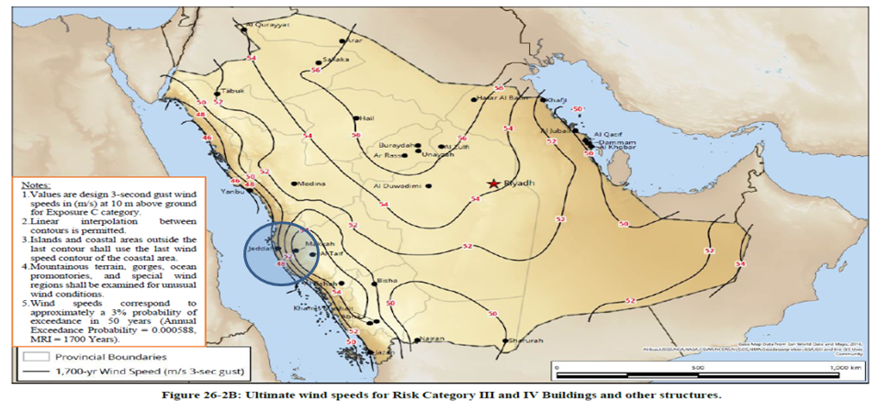

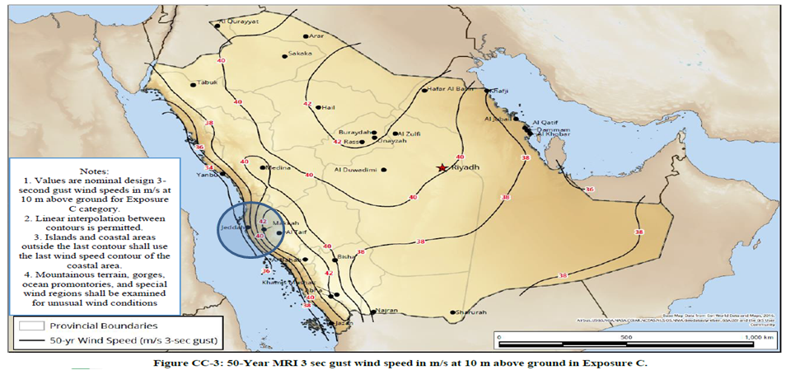

  - SEISMIC LOADS (E)

All structures and components shall be designed in accordance to SBC 201-CR-18, SBC 301-2018, ASCE 7-16 and IBC standards.

Jeddah City Seismic Data
PGA | 9.9%
Ss | 22.4%
S1 | 4.3%
TL | 4
Site Class | D (until geo-technical soil investigation report becomes available)
Fa | 1.6
Fv | 2.4
𝑆𝑀𝑆 = 𝐹𝑎 𝑆s | 1.6x0.224 = 0.3584
𝑆𝑀1 = 𝐹𝑣 𝑆1 | 2.4x0.043 = 0.1032
𝑆𝐷𝑆 =2/3 x 𝑆𝑀𝑆 | 2/3 x 0.3584 = 0.24
𝑆𝐷1 =2/3 x 𝑆𝑀1 | 2/3 x 0.1032 = 0.07
Seismic Design Category | Category B for Occupancy III  Category C for Occupancy IV

